

User manual

Employee Management System



Team Pesudo Maverics

Table of Contents

General Information 2

1. System Overview 2

1.1. Authorized user permissions 2

2. System features 2

2.1. Login 2

2.2. Employee creation 4

2.3. Project management 5

2.4. My Profile 7

2.5. Billing Management 7

2.6. Leave management 10

List of figures

Figure 1: Login screen 3

Figure 2: Welcome dashboard 4

Figure 3: Invalid credentials 5

Figure 4: Invalid Username 5

Figure 5: Employees Panel 6

Figure 6: Employee creation screen 6

Figure 7: Projects Panel 7

Figure 8: Project Creation screen 7

Figure 9: Project selection screen 8

Figure 10: Employee assignment screen 8

Figure 11: My profile section 9

Figure 12: Employee Billing screen 9

Figure 13: Employee billing submission screen. 10

Figure 14: Billing successful message 10

Figure 15: Employee Billing status check 10

Figure 16: HR Billing approval screen 11

Figure 17: Employee leave request screen 11

Figure 18: Employee Leave request submission form 12

Figure 19: Leave request successful message 12

Figure 20: Employee Leave request statuses 13

Figure 21: HR Leave Request submission statuses 13

# General Information

## System Overview

Companies can attract and keep the greatest personnel by using an employee management system that streamlines and automates HR procedures. Companies can use these systems to more successfully recruit and train employees, as well as keep track of a variety of data, such as personal information, compensation, and other details. This system has features such as leave management, project management, timesheet submission, and payroll management.

### Authorized user permissions

The user login is used to control the employee management system application. Admins and HR personnel can use the app to establish projects and approve user requests. Employees, on the other hand, can log onto the application to produce payrolls and send requests to HR, such as leave or timesheet requests.

## System features

Users can access the application using the below URL

[https://pseudomavericksems.xyz](https://pseudomavericksems.xyz/hr_admin/login.php)

### Login

#### HR USER

When you go to the URL, you'll be asked to choose between employee and HR users. You can switch based on your role.

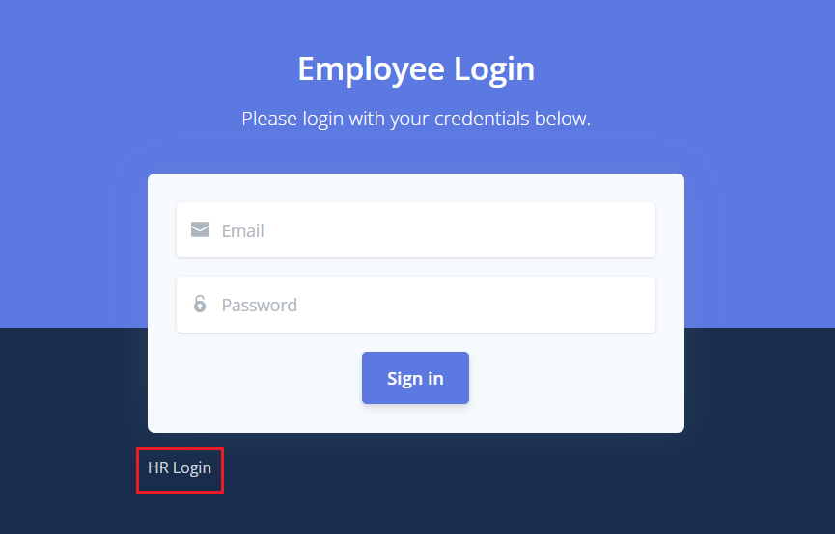

Figure 1: Login screen

You can see which screen you're on by looking at the header.

**Existing HR credentials:**

[hr1@gmail.com/asdfgh](mailto:hr1@gmail.com/asdfgh)

* For HR login, click on the HR login and enter the above credentials.
* Click on login.

#### Employee login

Employee credentials can only be created by HR. You can use those credentials to log in as an employee user once the employee user has been created.

**Existing employee credentials:**

* Switch to the employee login screen
* Enter the username and password.
* Click on login.

##### successful LOGIN

If you were successful in logging in, you will be taken to the application dashboard screen, which will display a welcome message.

Figure 2: Welcome dashboard

##### Invalid PASSWORD

If you entered an invalid password the following message will be displayed. “Email or password is incorrect”

Figure 3: Invalid credentials

##### Invalid username

If you entered invalid username, then the following message will be displayed. “Please include an @ in the email”

Figure 4: Invalid Username

### Employee creation

Only HR can create new employees into the application.

* Login as an HR user.
* Navigate to the employee panel. Here you can also view the existing employees in the system.
* Click on the **“Add new employee”**.
* Enter the user details and click on submit.

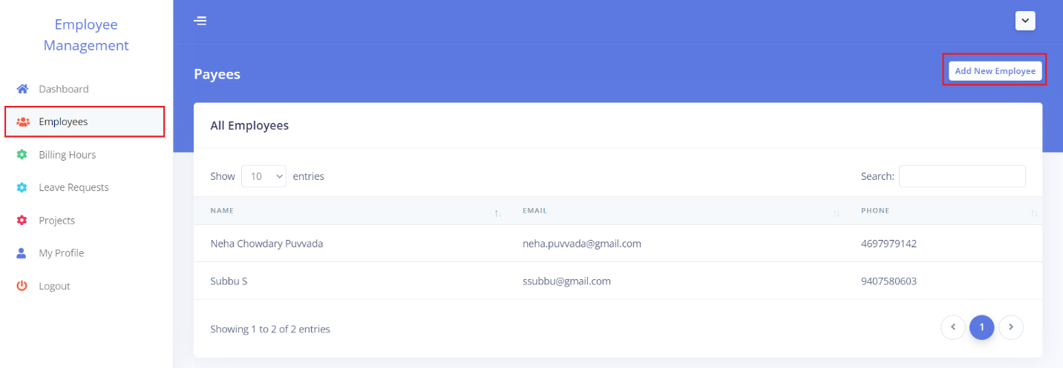

Figure 5: Employees Panel

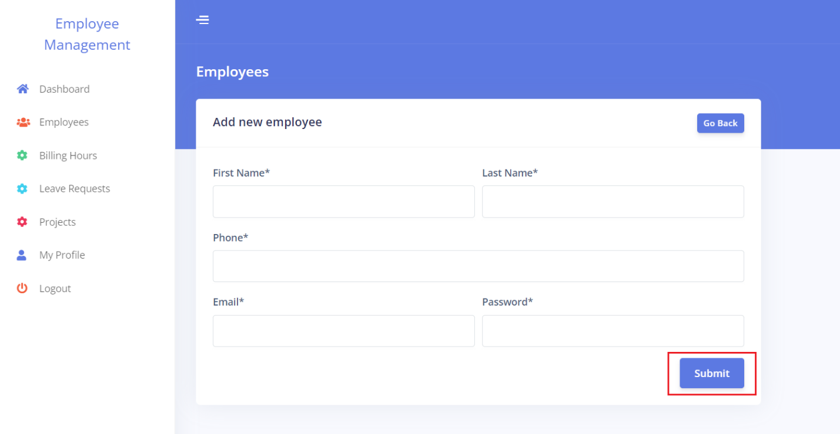

Figure 6: Employee creation screen

### Project management

Only HR can create new projects and assign employees.

#### Create a new project

For creating a new project in the application.

* Login as an HR user
* click on the projects panel.
* Click on Add new project.
* Provide the project details and click on submit.

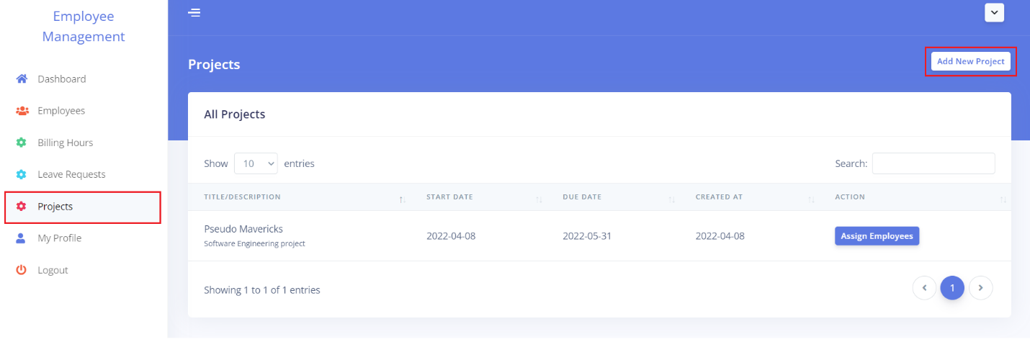

Figure 7: Projects Panel

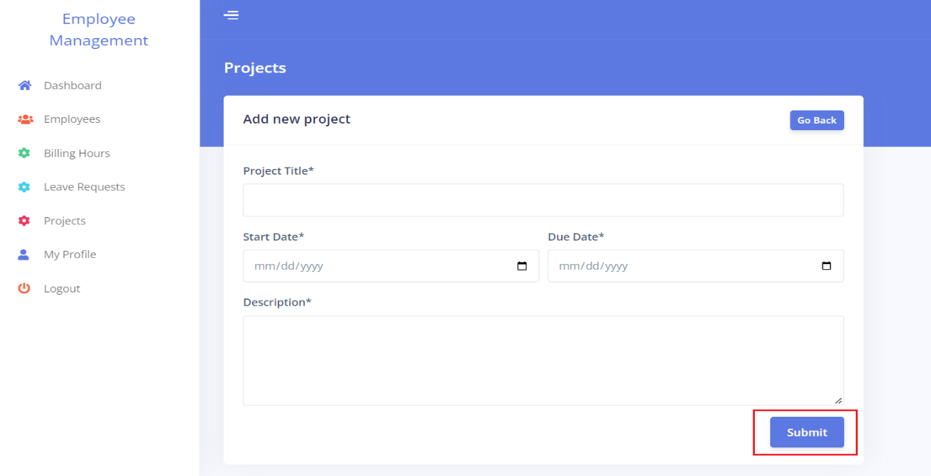

Figure 8: Project Creation screen

#### Assigning employees to the project

For assigning employees to the project.

* Login as an HR user.
* Navigate to the projects panel
* Choose the project you want to allocate employees to from the list, and click the **"Assign Employees"** button on the project you selected.
* Search for the employees, select the employee from the drop-down and click on submit.

Figure 9: Project selection screen

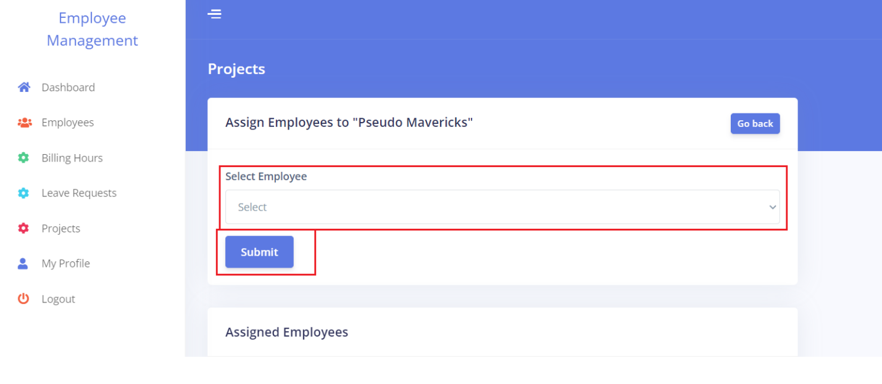

Figure 10: Employee assignment screen

### My Profile

This section is used to update the user information. Where users can update fields like Phone number and email. The user cannot be able to update the First Name and the last name. Users can also change their password using this section.

* Login as any user either HR or Employee.
* Navigate to the My Profile section.
* You can update the user information or can update the password.

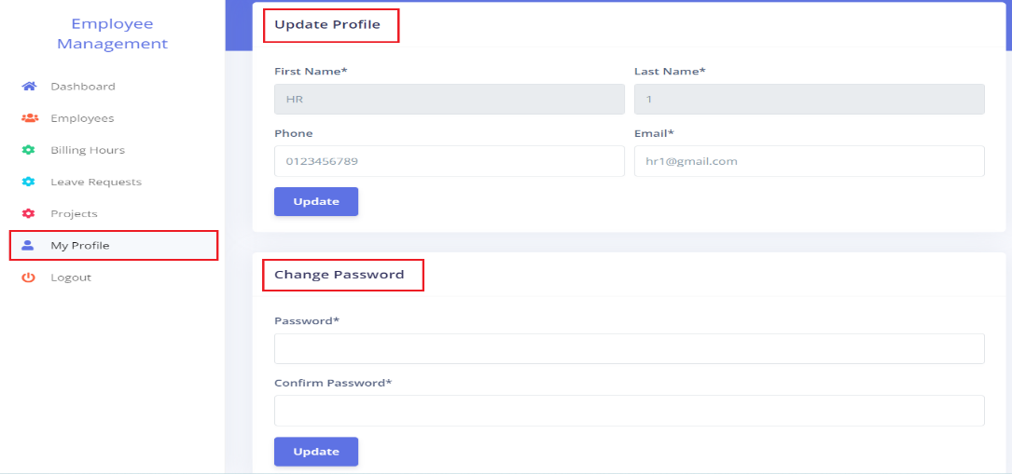

Figure 11: My profile section

### Billing Management

Here employees can submit their billing hours to HR and HR can approve the employee requests.

#### Employee Billing Management

The employee can submit their billing hours using the billing management.

* Login as an Employee user.
* Navigate to Billing hours.
* Click on the **“Submit Billing Hours”** button.

Figure 12: Employee Billing screen

* Enter the billing details and click on submit.

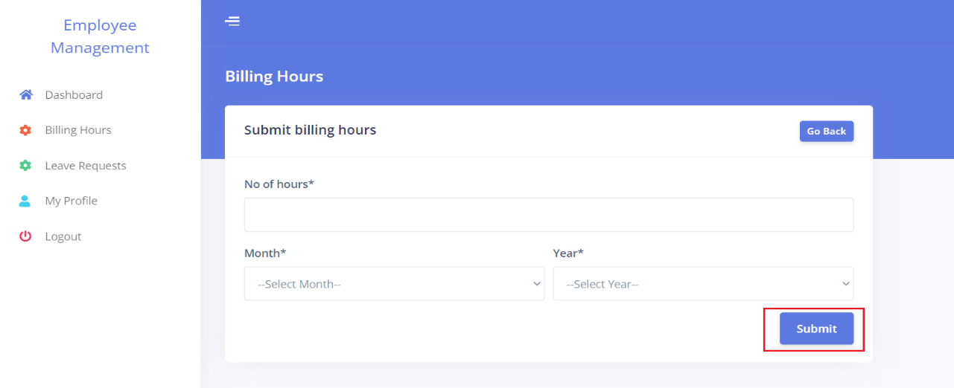

Figure 13: Employee billing submission screen.

* The following success message will appear once the user has successfully submitted the request.

Figure 14: Billing successful message

* Employees can also check the progress of their submissions.

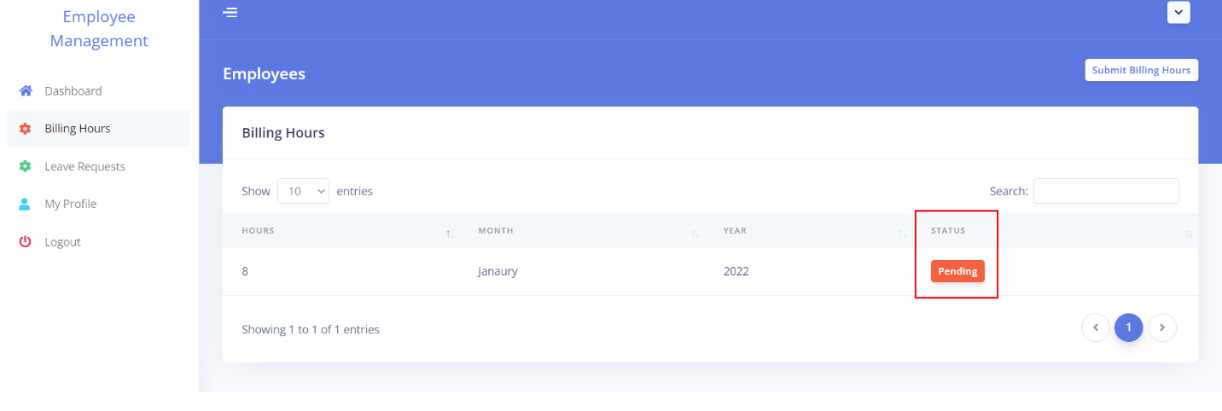

Figure 15: Employee Billing status check

#### HR Billing Management

Once the employee requests their billing requests, HR has access to approve them.

* Login as an HR user.
* Navigate to the billing panel.
* Click on the Accept button on the request submitted by the employee.
* HRs’s can also view the statuses of each request.

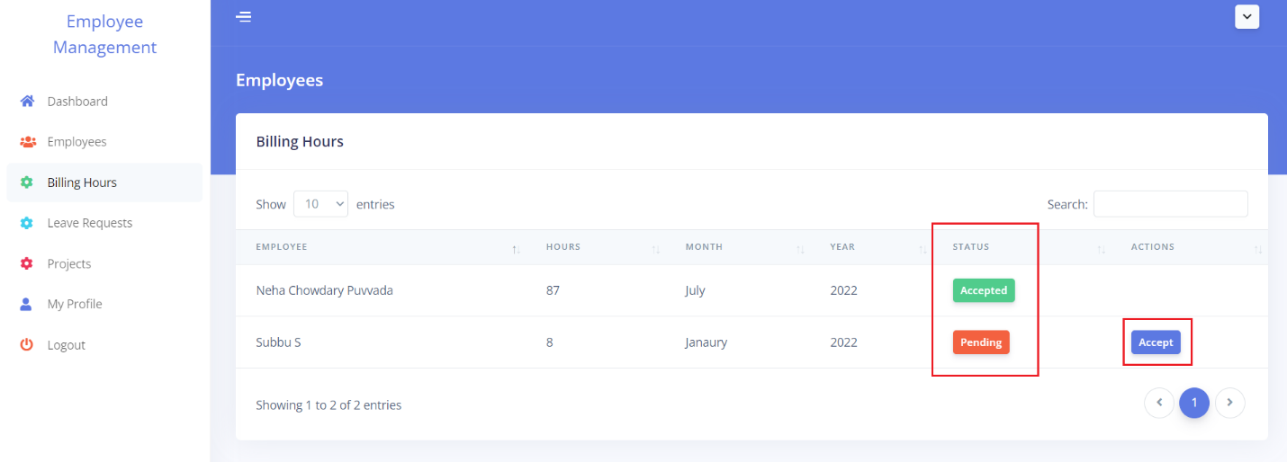

Figure 16: HR Billing approval screen

### Leave management

Employees can use this to submit their leave requests to HR, and HR can approve or deny the requests.

#### Employee leave management

The employee can submit the leave requests here.

* Login as an employee user.
* Navigate to leave management panel.
* Click on **“Submit Leave Request”**.

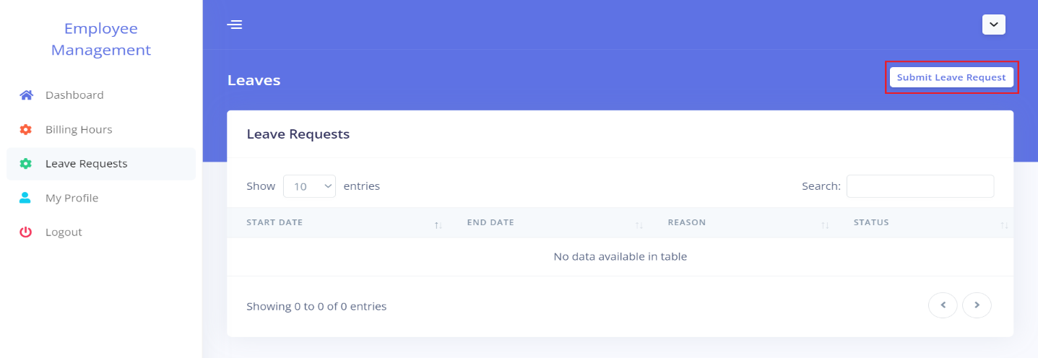

Figure 17: Employee leave request screen

* Enter the leave details and click on submit.

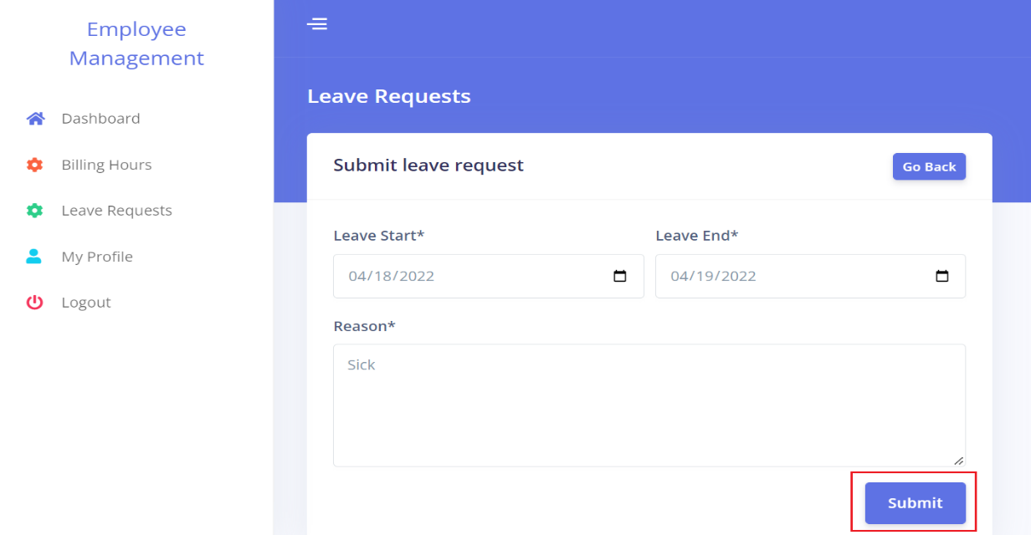

Figure 18: Employee Leave request submission form

* The following success message will be popped up once you have successfully submitted your request.

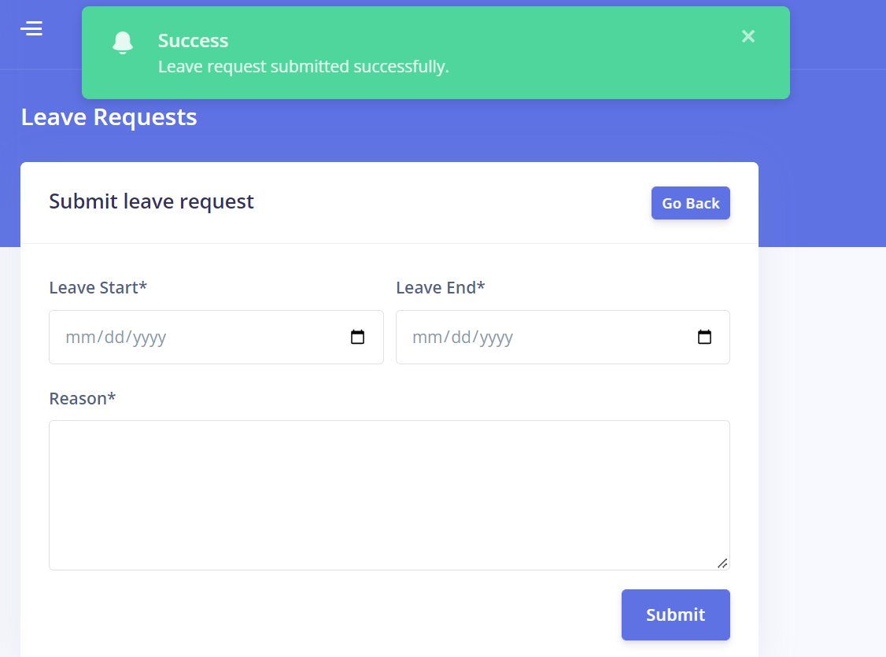

Figure 19: Leave request successful message

* Employeesee can also view the leave request submission statuses.

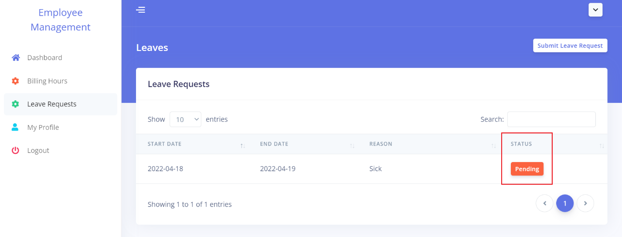

Figure 20: Employee Leave request statuses

#### HR leave management

Once an employee submits their leave requests to HR. HR has can approve the requests.

* Login as an HR user.
* Navigate to the leave management panel.
* Click on the accept submit on the request submitted by the employee.
* HR can also view the status of each request submitted by the employee.

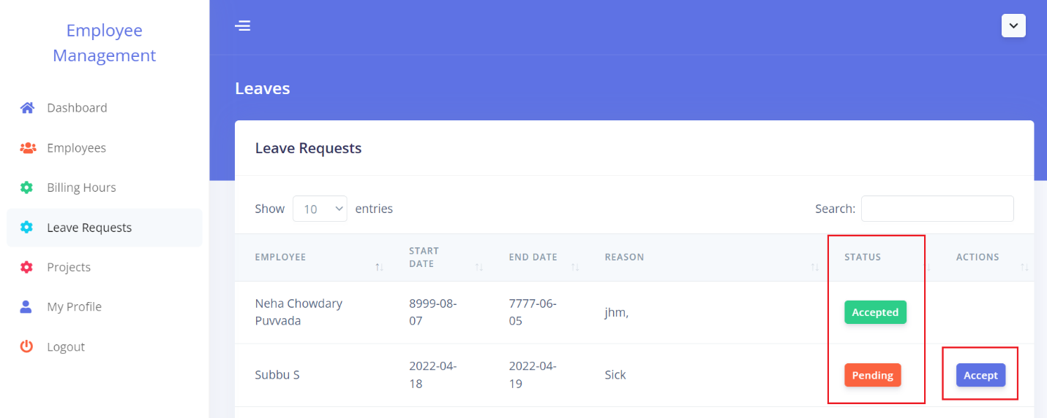

Figure 21: HR Leave Request submission statuses